Comparing the Recovery of Macao Visitors and Gaming Revenue
CISC7204 Data Science and Data Visualization
Assignment 02 Revised Pair Project Proposal Class B Pair 01
YE YUBO MC640763 | SUN JIAWEI MC640633

1 Project Topic Name
Region: Macao Special Administrative Region.
Domain: tourism and gaming.
Our project compares how visitor arrivals and gross gaming revenue recovered relative to 2019. We retain the annual comparison for 2019–2025 from Assignment 01 and add monthly comparisons for 2023–2025.
Main research question: Did visitor arrivals and gross gaming revenue in Macao return to their 2019 levels at the same speed?
Supporting questions: Which months had the largest and smallest recovery gaps? Did the typical monthly gap narrow or widen from 2023 to 2025? Does the monthly evidence support the annual comparison?

2 Project Purpose

Development from Assignment 01
Our first proposal used seven annual observations and one line chart. This proposal keeps the same topic and 2019 baseline, but adds 48 monthly observations per series. The completed analysis includes monthly recovery indices, a gap bar chart, and a box plot. This lets us investigate differences that annual totals cannot show.

Outcomes
As beginners in data science and data visualization, we want to practise completing a small project from finding reliable data to explaining the results. This project helps us apply what we have learned in CISC7204 to a concrete example using Macao public statistics. We hope to become more confident in choosing suitable charts and presenting evidence clearly in later assignments and research projects.

Skills
We want to become more comfortable using pandas to read CSV files, check missing values and duplicates, merge two tables, and calculate simple indices. We will practise line, bar, and box plots using Matplotlib, following the module exercises. Working in a pair also lets us practise checking each other’s calculations, discussing chart choices, and writing a clear explanation together.

Knowledge
We want to understand why visitor counts and revenue cannot be compared directly on one scale, and how a common baseline makes them comparable. We will learn the difference between a percentage and a percentage point gap, how monthly patterns can differ from annual totals, and why a relationship in a chart does not prove a cause. We also hope to better understand Macao’s tourism and gaming recovery.

3 Project Tasks

Data sources and preparation
Visitor arrivals are taken from DSEC through the Macao Government Tourism Office (MGTO, n.d.). Gaming data are from the Gaming Inspection and Coordination Bureau (DICJ, n.d.-c, n.d.-d, n.d.-e, n.d.-f). Each monthly input contains the 12 months of 2019, 2023, 2024, and 2025. Visitors are arrival counts, not unique people; gaming revenue is nominal and measured in million Macao patacas.
The analysis merges the files by Year and Month and checks for missing values, duplicates, and incorrect units. The result has 48 unique matched rows and 36 recovery months. Annual totals provide the original background (DICJ, n.d.-a, n.d.-b; Government Information Bureau, 2024; Statistics and Census Service, 2025, 2026).
Visitor monthly sums match all four annual totals. Gaming sums match in 2023–2025. In 2019, the published monthly values sum to 292456 million MOP, versus the published annual value of 292455. We retain both measures and record the small difference. The 2025 annual gaming value is updated from the rounded 247400 in Assignment 01 to the published 247404 million MOP.

Calculations
For each year y and month m, we compare the value with the same month of 2019:
Visitor index = Visitors(y, m) / Visitors(2019, m) × 100
Gaming index = Revenue(y, m) / Revenue(2019, m) × 100
Recovery gap = Visitor index − Gaming index
An index of 100 matches the 2019 month. A positive gap means that visitor recovery is higher, measured in percentage points. We calculate the mean and median of each year’s 12 gaps. Annual indices use published annual totals. Calculations retain full precision; the text reports one decimal place.
Figure 1
Annual recovery of visitors and gaming revenue
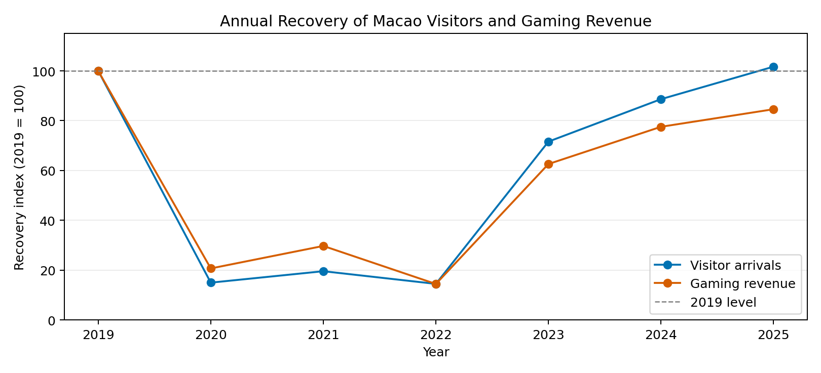
Note. In 2025, visitor arrivals reached 101.7% of the 2019 annual level, while gaming revenue reached 84.6%. This retains and verifies the comparison from Assignment 01.

Monthly comparisons and visual justification
Figure 2
Monthly recovery relative to the same month in 2019
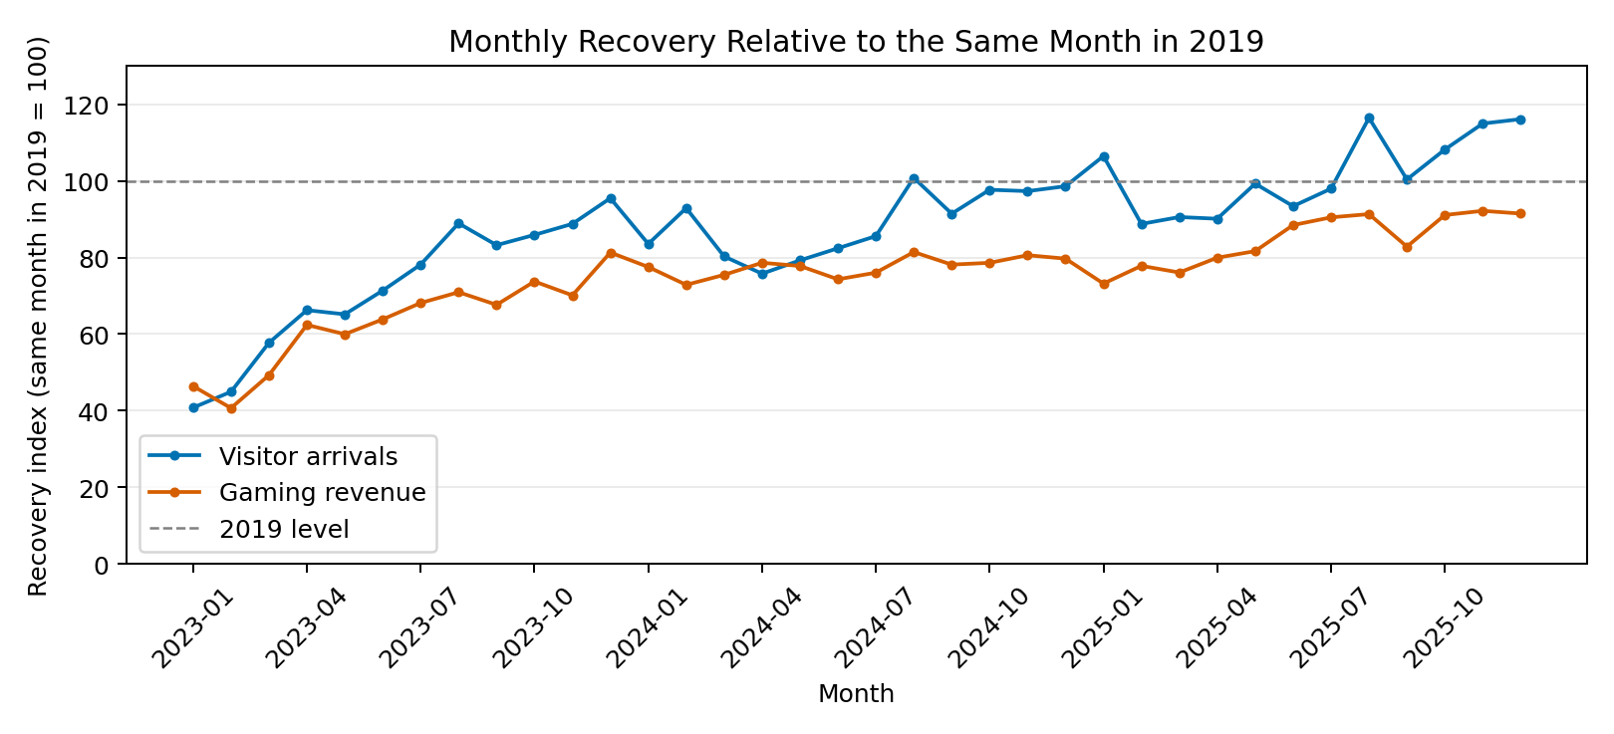
Note. All 36 months from January 2023 to December 2025 are shown. Visitor arrivals reached the baseline in 0, 1, and 6 months in 2023, 2024, and 2025, respectively. Gaming revenue did not reach it in any month.
Figure 3
Monthly recovery gap between visitors and gaming revenue
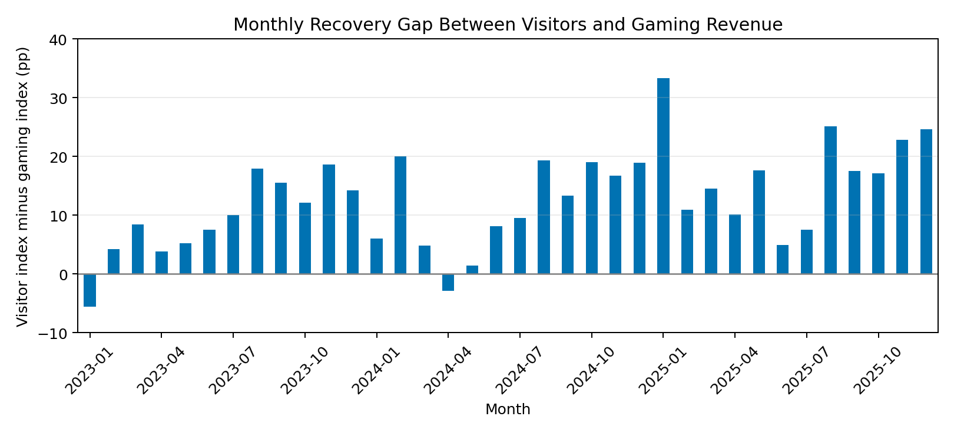
Note. The largest gap was 33.3 percentage points in January 2025 (indices 106.5 and 73.2); the smallest was −5.6 in January 2023. Visitor recovery was higher in 34 of 36 months.
The line chart puts the two indicators on a common recovery scale. Its reference line shows whether each has returned to its corresponding 2019 monthly level. The bar chart makes the size and direction of the difference easier to see and identifies months hidden by annual totals.
Together, the figures answer the original question and the new monthly questions. They show different recovery paths, including months when visitor recovery was lower. Comparing the same calendar month reduces usual seasonal differences, but it does not fully adjust for seasonality or moving holidays. These charts describe differences without establishing their causes.

Distribution of monthly recovery gaps
Figure 4
Monthly recovery gaps by year
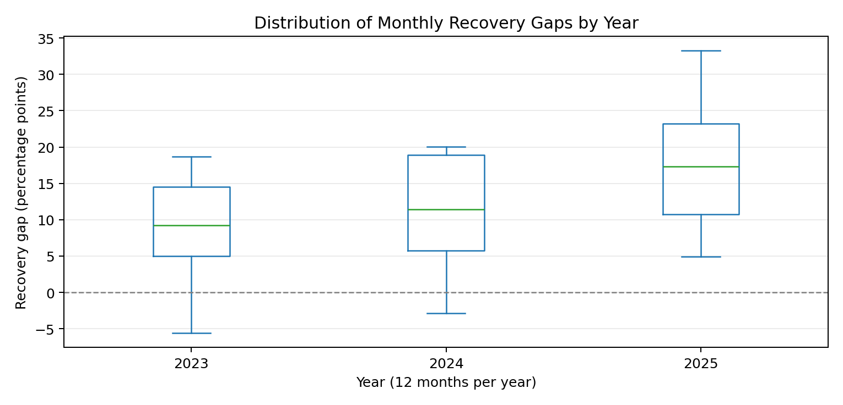
Note. Each box summarizes 12 months. Median gaps were 9.2, 11.4, and 17.3 percentage points; mean gaps were 9.3, 11.2, and 17.2. The middle line is the median and the box covers the middle 50%.
Both summaries show a wider typical gap by 2025. This does not mean that the gap rose every month. Revenue is not adjusted for inflation; visitors do not all gamble, and gaming revenue may include residents’ spending. Moving holidays and visitor composition may affect the comparison. We do not make a causal claim.

4 Project Criteria for Success
Our checklist requires documented official sources, complete months, correct baseline calculations, explained annual differences, readable chart labels and source notes, and conclusions that answer the questions. The Notebook runs all eight code cells and exports four figures and calculation tables.

5 Project Collaboration
We divide the data processing, analysis, and writing tasks as follows.
Member | Data processing | Analysis and written outputs
YE YUBO  MC640763 | Collect and clean visitor records; check year and month labels, missing values, duplicates, and yearly totals. | Prepare the annual comparison; summarize mean and median gaps and the box plot; draft the purpose and results discussion.
SUN JIAWEI  MC640633 | Collect and clean gaming records; check units and monthly versus cumulative values; merge the datasets and match 2019 months. | Calculate recovery indices and gaps; prepare the monthly line and bar charts; maintain the Notebook and draft the methods.
Both members | Cross-check each other’s data and calculations; run the complete Notebook together. | Discuss chart choices and conclusions, explain exceptions and limitations, and revise the final proposal together.

AI assistance:
We used ChatGPT to search some related python syntaxes and optimized our python codes. It helped refine the Word document's formatting and supplemented or polished certain sentences to make them more formal.

References
Gaming Inspection and Coordination Bureau. (n.d.-a). Gaming statistics for 2021 [Data set]. Retrieved October 20, 2026, from https://www.dicj.gov.mo/web/cn/information/DadosEstat/2021/content.html
Gaming Inspection and Coordination Bureau. (n.d.-b). Gaming statistics for 2025 [Data set]. Retrieved October 20, 2026, from https://www.dicj.gov.mo/web/pt/information/DadosEstat/2025/content.html
Gaming Inspection and Coordination Bureau. (n.d.-c). Monthly gross revenue from games of fortune in 2019 and 2018 [Data set]. Retrieved October 20, 2026, from https://www.dicj.gov.mo/web/en/information/DadosEstat_mensal/2019/report_en.xml
Gaming Inspection and Coordination Bureau. (n.d.-d). Monthly gross revenue from games of fortune in 2023 and 2022 [Data set]. Retrieved October 20, 2026, from https://www.dicj.gov.mo/web/en/information/DadosEstat_mensal/2023/report_en.xml
Gaming Inspection and Coordination Bureau. (n.d.-e). Monthly gross revenue from games of fortune in 2024 and 2023 [Data set]. Retrieved October 20, 2026, from https://www.dicj.gov.mo/web/en/information/DadosEstat_mensal/2024/report_en.xml
Gaming Inspection and Coordination Bureau. (n.d.-f). Monthly gross revenue from games of fortune in 2025 and 2024 [Data set]. Retrieved October 20, 2026, from https://www.dicj.gov.mo/web/en/information/DadosEstat_mensal/2025/report_en.xml
Government Information Bureau. (2024). Tourism. In Macao yearbook 2024 (Appendix 19). https://yearbook.gcs.gov.mo/uploads/yearbook_pdf/2024/myb2024eAP19.pdf
Macao Government Tourism Office. (n.d.). Total visitor arrivals [Data set]. Retrieved October 20, 2026, from https://dataplus.macaotourism.gov.mo/Indicator/VisitorsSummary/SummaryBar?lang=E&periodtype=M&start=241&end=324
Statistics and Census Service. (2025, January 21). Visitor arrivals for December and the whole year of 2024. Government Information Bureau. https://www.gcs.gov.mo/news/detail/en/N25AUB2Zwi
Statistics and Census Service. (2026, January 23). Visitor arrivals for December and the whole year of 2025. Government Information Bureau. https://www.gcs.gov.mo/news/detail/en/N26AWC98hd

